LITERATURE REVIEW & SUMMARY
Mini Project: Teacher Recruitment Website
Synthesis of six research papers informing the design of an online teacher recruitment and selection system
1. Review of the Six Research Papers
Paper 1. Miller et al. (2019), JNAAC — Alternate-Route Teacher Recruitment in Rural Mississippi (MSU MATM program)
Problem: Rural teacher shortage with a hard-to-reach candidate pool; only 21% of the state population holds a bachelor’s degree, and isolation/low pay make rural posts hard to fill.
Method & findings: A fully online Master of Arts in Teaching (middle level) program recruited, prepared and placed teachers over five years — 154 participants started and 113 were hired (avg. 22 new teachers/year). The authors identify three strategy families: (a) fostering and maintaining relationships with school principals, university faculty advisors and current students, where word-of-mouth proved the most cost-effective channel; (b) targeting appropriate audiences via state conferences, community job fairs, campus events and sponsorships; (c) using varied communication methods — a functional website (top awareness source), targeted Facebook advertising (page likes grew ~2,000% in 3 months), newspapers, TV segments, posters and promotional items.
Take-away: The website and social media are the primary attraction channels; referral/word-of-mouth loops and sustained program quality drive recruitment success.
Paper 2. Zulfikar et al. (2018), AASEC/IOP — Teacher Recruitment System Using SAW and TOPSIS
Problem: Subjectivity and inconsistency in manual teacher selection risk placing unsuitable teachers in classrooms, lowering school quality.
Method & findings: A decision-support model scoring 13 candidates on 7 weighted criteria (communication skill, educational background, general knowledge, tilawah & tahfidz, appearance, work experience, GPA). Both SAW and TOPSIS ranked A10, A3 and A1 as the top three — exactly the candidates actually accepted at the Al-Mishbah Foundation; only minor rank differences occurred at positions 6–9, with TOPSIS slightly more discriminating.
Take-away: This is the core justification for the website’s automated shortlisting/scoring engine: MCDM methods produce consistent, defensible rankings that match real hiring decisions.
Paper 3. Turnip et al. (2019), SNIKOM/IOP — Teacher Performance Assessment DSS Using SMART
Problem: Conventional teacher assessment in Indonesian schools is slow and delays decision-making.
Method & findings: A web-based DSS with role-based logins (admin, principal, teacher) assessing four criteria — pedagogic, personality, social, professional. SMART swing weighting sets the most important criterion at 100 and the least at 10, normalises and averages the weights, then computes utility scores to rank teachers. Results showed a significant difference in decision time and quality before vs. after system use; full UML modelling (use case, class, sequence, activity diagrams) guided implementation.
Take-away: A reusable SMART ranking module with configurable criteria and role-based access fits naturally into the recruitment website.
Paper 4. Klassen et al. (2025), Computers & Education — Digital Innovations in Teacher Recruitment
Problem: Teacher shortages are worsened by Gen-Z applicants’ disengagement from traditional, non-interactive recruitment messages.
Method & findings: A two-phase randomised experiment (N = 957, UK undergraduates) compared a persuasive game (“TeachQuest”), a realistic job preview (RJP), and a neutral control game. Both interventions increased teaching interest and person-vocation fit; the RJP also increased teaching self-efficacy; immersion experiences sustained interest at a six-week delayed post-test. Only ~6.9% clicked through to the government ITE website (non-significant).
Take-away: Add engaging, interactive digital content — realistic job previews, videos, gamified elements — to attract and inform young applicants.
Paper 5. Mankki (2026), Teaching & Teacher Education — Mentoring Expertise in SBTE Recruitment (Finland)
Problem: Mentoring is central to school-based teacher educators’ work, yet its role in recruitment is unclear and under-researched.
Method & findings: Analysis of 158 job advertisements plus interviews with 8 teacher-training-school principals showed mentoring is mentioned only vaguely (typically one sentence) in ads. Principals prioritise solid classroom teaching skill, treat mentoring as learnable on the job, value openness/dialogue, and see prior mentoring experience as an advantage — yet deliberately avoid strict experience requirements because they shrink an already small applicant pool.
Take-away: Write clear, specific job advertisements and balance criteria carefully: over-restrictive requirements deter good candidates and narrow the pool.
Paper 6. Hogan (1988), University of Northern Iowa — Teacher Recruitment and Selection Methods and Procedures
Problem: Teacher recruitment was historically passive and selection unstructured, biased and legally risky.
Method & findings: This classic paper synthesises best practices: widen the recruitment base beyond local applicants; use structured interviews (improving reliability, validity and applicability); gather multiple information sources beyond credentials (work samples, demonstrations); train interviewers continuously; document every decision; guard against non-task biases (age, gender, appearance, stereotypes); and provide orientation/induction for new hires.
Take-away: The foundation for the website’s structured interview module, evaluation rubrics, and decision documentation/audit trail.
2. Evidence from Decision-Support Experiments
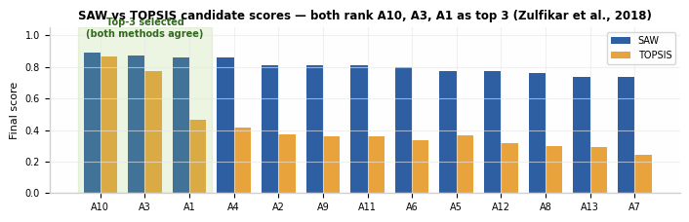
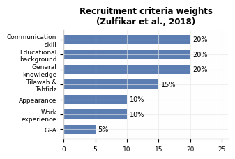
Fig. 1 (top): SAW and TOPSIS produce nearly identical rankings — MCDM gives consistent, defensible shortlists. Fig. 2: criteria and weights must be configurable per vacancy.
3. Synthesis — What the Literature Says
Across the six papers a consistent two-sided model emerges. On the ATTRACTION side, reach candidates where they are — web, social media, referrals, events — with authentic, engaging content (Klassen; Miller; Mankki). On the SELECTION side, replace gut-feel with structured, criteria-based, documented evaluation (Hogan), supported by transparent multi-criteria decision models — SAW, TOPSIS, SMART — which demonstrably reduce subjectivity and match real hiring outcomes (Zulfikar; Turnip). Fairness warnings recur throughout: keep criteria job-related, avoid over-restrictive experience demands that shrink the pool (Mankki), document every decision for legal defensibility (Hogan), and recognise that financial incentives alone do not recruit — relationships and program quality do (Miller).
4. Implications — Features of the Proposed Website
F1. Job Portal & CMS: Post vacancies with clear, specific criteria (Mankki); publish realistic previews/videos (Klassen).
F2. Online Application: Structured forms, document upload, and application status tracking (Miller; Hogan).
F3. Automated Shortlisting Engine: Configurable criteria & weights; computes SAW, TOPSIS and SMART scores and ranks candidates (Zulfikar; Turnip).
F4. Interview Management: Panel scheduling, structured evaluation rubric, consensus scoring, and interviewer training notes (Hogan).
F5. Communication & Notifications: Email/SMS status updates, feedback loops, and referral tracking (Miller).
F6. Reports & Dashboard: Rankings, charts, and decision logs/audit trail for transparency and legal compliance (Hogan; Zulfikar).
5. Proposed System Architecture
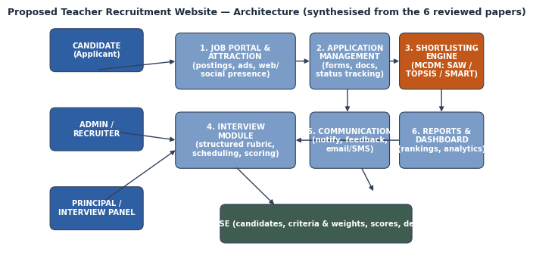
Conclusion: The reviewed literature supports a web platform that couples modern digital attraction (web/social presence, engaging previews) with objective, MCDM-based shortlisting and structured interviews — delivering faster, fairer, well-documented teacher recruitment than conventional manual practice.

